Brookside Curriculum Overview – English (Year 4)

 | Spring 1 | Spring 2
Reading objectives | Justify inferences with evidence.  Summarise main ideas drawn from more than one paragraph.  Identify how language, structure and presentation contribute to meaning. | To draw inferences referring to characters’ feelings, thoughts and motives.  Justify inferences with evidence.  Summarise main ideas drawn from more than one paragraph.
Core texts | 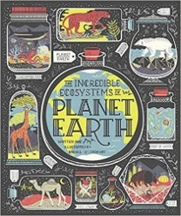  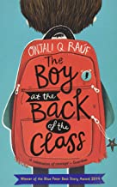 | 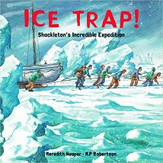  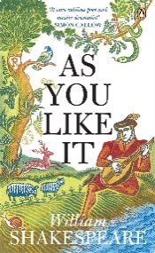
Writing | Diary extracts  Descriptive Narratives  Speech  Information Texts  Newspaper articles | Diary extracts  Newspaper articles  Formal and informal letters  Persuasive writing  Poetry
Grammar & Punctuation | - Sentence types and conjunctions  - Commas  - Inverted commas  - Fronted adverbials | - Prepositional phrases  - Expanded nouns phrases  - Commas to separate clauses
Spelling | - Homophones and near homophones  - Apostrophe for possession (including plurals) and omission  - Prefixes: in, il, im, ir | - Prefixes: auto, anti, ex, inter, sub, super, mis, re, dis  - Further homophones and near homophones
Handwriting | - Increase legibility, consistency and quality of their handwriting.  - Understand which letters, when adjacent to one another, are best left enjoined.
Home | - Please read four times a week.  - Practice your spellings (little and often is better).  - We would love to see any additional writing that you do at home.

