Brookside Curriculum Overview – English (Year 3)

 | Spring 1 | Spring 2
Reading objectives | Read aloud and understand words based on knowledge of root words, prefixes and suffixes.  Identify themes and conventions in a range of books.  Identify main ideas from a paragraph and summarise.  Recognise and perform different types of poetry. | Draw inferences.  Justify inference with evidence.  Ask questions to improve understanding  Identify how language structure and presentation contribute to meaning.  Read fluently using expression.
Core texts | 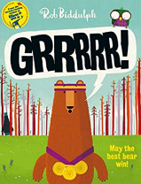  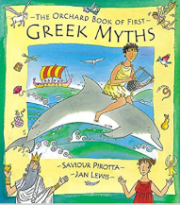  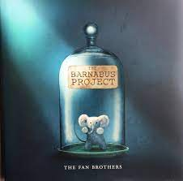 | 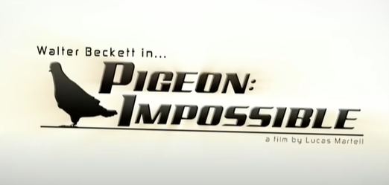  Pigeon Impossible  By Lucas Martell  Soar  By Alyce Tzue  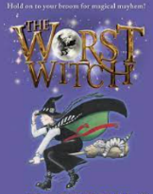
Writing | Read, write and perform poetry  Write a post card  Retell a story  Recount  Narrative  Myths | Newspaper report  Diary  Narrative  Learning to use a dictionary
Grammar & Punctuation | - Fronted adverbials  - Adverbial phrases  - Paragraphs  - Prepositions  - Subordinating conjunctions  - Expanded noun phrases | - Subordinating conjunctions  - Coordinating conjunctions  - Use determiners ‘a’ and ‘an’ correctly
Spelling | - Words with short ‘I’ sound spelt ‘y’  - Adding suffixes – not doubling the last consonant  - Adding suffixes – doubling the final consonant  - Using prefix -mis  - Using prefix -dis  - Words with a ‘k’ sound spelt with a ‘ch’ | - Homophones  - Homophones  - Adding prefix bi- and re- to words  - Words ending in the ‘g’ sound spelt like ‘gue’ and the ‘k’ sound spelt like ‘que’  - Words with a ‘sh’ spelt ‘ch’  - Statutory spelling challenge words
Handwriting | To increase the legibility, consistency and quality of their handwriting focusing on letter formation, cursive joins and correct size.
Home | - Read 3 times a week and record in Reading Records.  - To read and enjoy Reading Challenge text when this is sent home.  - Learn spelling rules, ‘remember how to’ and tricky words for a weekly spelling test and application in their writing.

