Brookside Curriculum Overview – English (Early Years)

 | Spring 1 | Spring 2
Communication and Language  Literacy  EYFS Development Matters 2020 | Engage in story times.  Engage in non-fiction books.  Listen to and talk about selected non-fiction to develop a deep familiarity with new knowledge and vocabulary.  Demonstrate understanding of what has been read to them by retelling stories and narratives using their own words and recently introduces vocabulary. | Engage in story times.  Say a sound for each letter in the alphabet and at least 10 digraphs.  Read words consistent with their phonic knowledge by sound-blending.  Use and understand recently introduced vocabulary during discussions about stories, non-fiction, rhymes and poems and during role-play.  Demonstrate understanding of what has been read to them by retelling stories and narratives using their own words and recently introduces vocabulary.
Core texts | 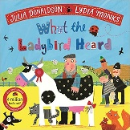  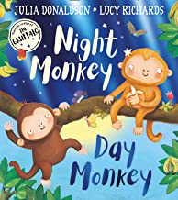  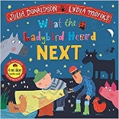  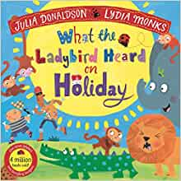  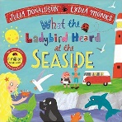  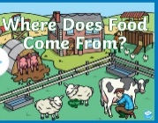  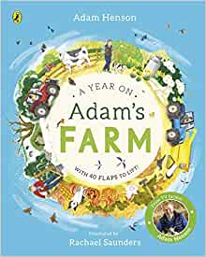  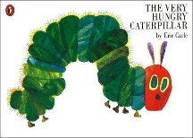 | 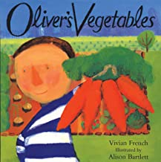  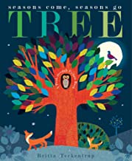  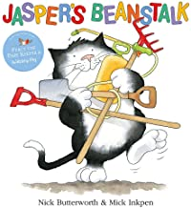  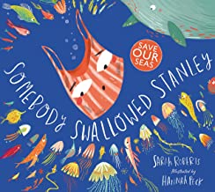  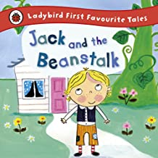  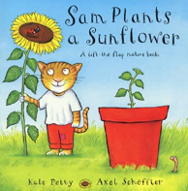  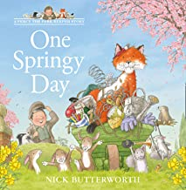  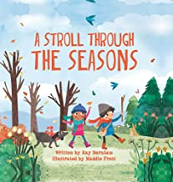
Phonics | Phase 3  j, v, w, x, y, z, qu, ch, sh, th, ng  Revision of Phase 2 Tricky Words - to, the, no, go, I  Phase 3 Tricky Words – he, she, we, me, be  Tricky Words (Spelling) to, the, no, go, I | Phase 3  ai, ee, igh, oa, oo (long), oo (short), ar, or, ur, ow, oi, ear, air, ure, er  Phase 3 Tricky Words – was, my, you, they, here, all, are
Writing | Write words by identifying the sounds and then writing the sound with letter/s.  Simple sentences of 4 or 5 words. | Write simple phrases and sentences that can be read by others.  Re-read what they have written to check that it makes sense.
Vocabulary, Grammar & Punctuation | Capital letters, finger spaces and full stops
Spelling & Handwriting | Beginning to sound out and spell CVC and CVCC words that are consistent with their phonics knowledge, including some tricky words.  Begin to form lower case and capital letters correctly | Continue to sound out and spell CVC and CVCC words that are consistent with their phonics knowledge, including some tricky words.  Form all lower case and capital letters correctly.
Spoken Language | - Articulate their ideas and thoughts in well-formed sentences.  - Ask questions to find out more and to check they understand what has been said to them.  - Learn new vocabulary and use in discussions. | - Participate in small group, class and 1:1 discussion, offering their own ideas using recently introduced vocabulary.  - Offer explanations for why things might happen, making use of recently introduced vocabulary from stories, non-fiction, rhymes and poems where appropriate.
Home | - Reading diary checked, reading books changed and sent home once per week  - Reading words checked and changed once per week. A new set will be sent home when children can confidently read their current set.  - Sharing books independently exchanged and sent home on a Monday.  - Parents/Carers informed of key text/theme each week on external Early Years notice board.

